And But Therefore (ABT) Narrative - Innovation/ Startup Pitch Framework

Contents

Contents 1
ABT Narrative Template with examples 1
Visual Strategy Mapping Template 3

ABT Narrative Template with examples

What (Problem focus: ordinary world, problem to solve):
Functional pains
Keeping devices charged is challenging, and larger batteries in devices are expensive, heavy, make devices larger than they need to be, and environmental damage at end-of-life

And (USER FOCUS: what's at stake)
Social/ emotional pains
users feel stressed keeping the devices charged to use them, see battery levels fall below 50%, and have to stay plugged in or having to be deliberate about fully charging devices at night or interrupt their flow or be restrained to somewhere they can be plugged inday,

But (Product Focus: product solution)
Functional Gains
“wireless charging anywhere“ is now available, that isn’t limited to a desk, or to 1 or 2 devices at a time, and you can use while charging without being plugged into a portable battery or having to be plugged in to a wall

Therefore (USER gain focus: customer benefit)
Social/Emotional Gains
Users are no longer limited to where they have to charge their devices. They can use their devices more freely, and products can be made smaller, cheaper, more attractive and less damaging to the environment. Users can focus on charging just 1 battery instead of many devices and can forget about topping up their device charge during the day.

Visual Strategy Mapping Template
From the ABT, visually map out the strategy for intuitively presenting it to someone
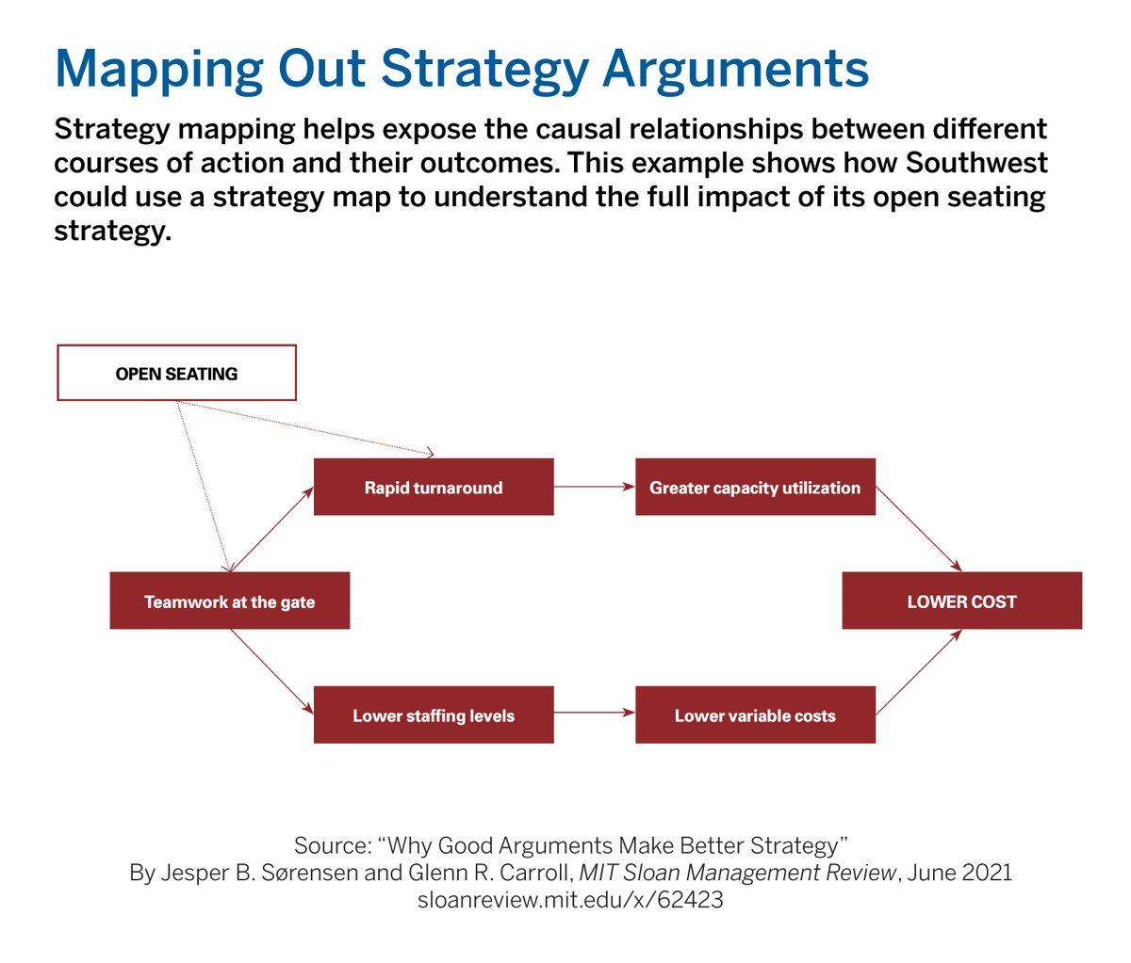

ABT Examples

